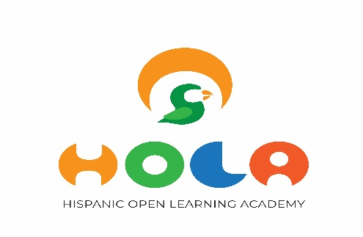

holaspanishclasses.com
patricia@holaspanishclasses.com
416-884-7145

Student Application Form

Student
Full Name: |  |  |  | DOB:
 | Last | First | M.I.

Address:
 | Street Address | Apartment/Unit #

 | City | Province | Postal Code

Phone: |  | Email

Parents
Mother’s Full Name:
 | Last | First | M.I. |  | Phone

Father’s Full Name:
 | Last | First | M.I. |  | Phone

Emergency Contact
Please list two persons to notify in case of emergency
Full Name: |  | Relationship:
Email: |  | Phone:
Full Name: |  | Relationship:
Email: |  | Phone:

Signature: |  | Date:
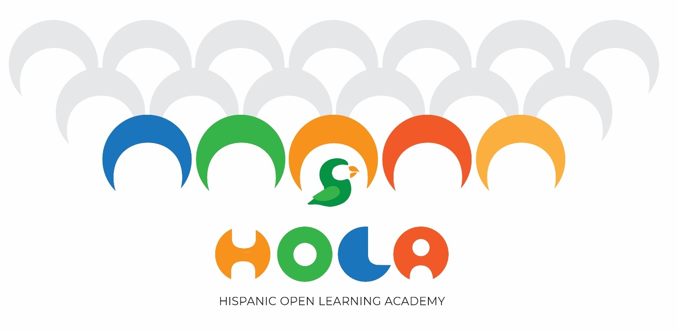

Two terms of 10 weeks each, 60-minute class
Once a week on Wednesday or Friday (24 hours notice if you need to switch days)
Twice a week on Wednesday and Friday
From 3:20 to 4:20PM
Hour Tuition: $25 + HST

First term: February 4th to April 16th
Second term: April 21st to June 25th

Options:

Course Class Duration Total hours Tuition

Once per week (1Xw) 1 hour 10 Weeks 10 $ 250.00 + HST
Twice per week (2Xw) 2 hours 10 Weeks 20 $ 480.00 + HST
Tuition can be paid as a lump sum or in monthly installments by e-transfer to patricia@holaspanishclasses.com or a cheque made out to Hispanic Open Learning Academy.

For parents who are registering their child/children for twice-a-week classes, payment can be made in 3 installments (Feb/March/April). Also, a discount of 10% for siblings is applied.

We love giving back to the community! As a token of appreciation, HOLA will be donating 5% of the enrollment fees to your school.

